**Hadoop1 and Hadoop2**

Changes are done on both HDFS and MapReduce side. Hadoop2’s MapReduce is called MapReduce2 or YARN also.

**HDFS**:

**HDFS in Hadoop1**

NameNode

* manages the File System's namespace/meta-data/file blocks.
* It maintains 'Namespace Image' and 'Edit Logs'. Namespace Image has all metadata like block information, permissions, data node information etc. Edit Logs has all activities. (VERY IMPORTANT)
* It is recommended to have 1GB main memory in NameNode for million storage blocks

Secondary NameNode (replaced by CheckpointNode and StandbyNameNode in hadoop2)

* Performs housekeeping work so NameNode doesn’t have to. Primary NameNode keeps edit logs in memory, so there has to somebody who keeps managing these logs and namespace image for faster recovery, if primary namenode fails. As it is a resource consuming process, another node Secondary NameNode is here in Hadoop to do this job. That's it.
* Requires similar hardware as Namenode machine
* Not used for high-availability – NOT a Backup for Namenode

The NameNode stores modifications to the file system as a log appended to a native file system file, edits. When a NameNode starts up, it reads HDFS state from an image file, fsimage, and then applies edits from the edits log file. It then writes new HDFS state to the fsimage and starts normal operation with an empty edits file. Since NameNode merges fsimage and edits files only during start up, the edits log file could get very large over time on a busy cluster. Another side effect of a larger edits file is that next restart of NameNode takes longer.

The Secondary NameNode(Checkpoint Node) merges the fsimage and the edits log files periodically and keeps edits log size within a limit. It is usually run on a different machine than the primary NameNode since its memory requirements are on the same order as the primary NameNode.

The start of the checkpoint process on the secondary NameNode is controlled by two configuration parameters.

<https://hadoop.apache.org/docs/r2.7.1/hadoop-project-dist/hadoop-hdfs/HdfsUserGuide.html#Secondary_NameNode>

- dfs.namenode.checkpoint.period, set to 1 hour by default, specifies the maximum delay between two consecutive checkpoints, and

- dfs.namenode.checkpoint.txns, set to 1 million by default, defines the number of uncheckpointed transactions on the NameNode which will force an urgent checkpoint, even if the checkpoint period has not been reached.

The secondary NameNode stores the latest checkpoint in a directory which is structured the same way as the primary NameNode’s directory. So that the check pointed image is always ready to be read by the primary NameNode if necessary.

**HDFS in Hadoop2**

StandbyNameNode

Secondary Namenode is replaced by **StandbyNameNode** which actually acts as a NameNode, if primary NameNode fails. This overcomes Single Point of Failure problem of Hadoop 1.x

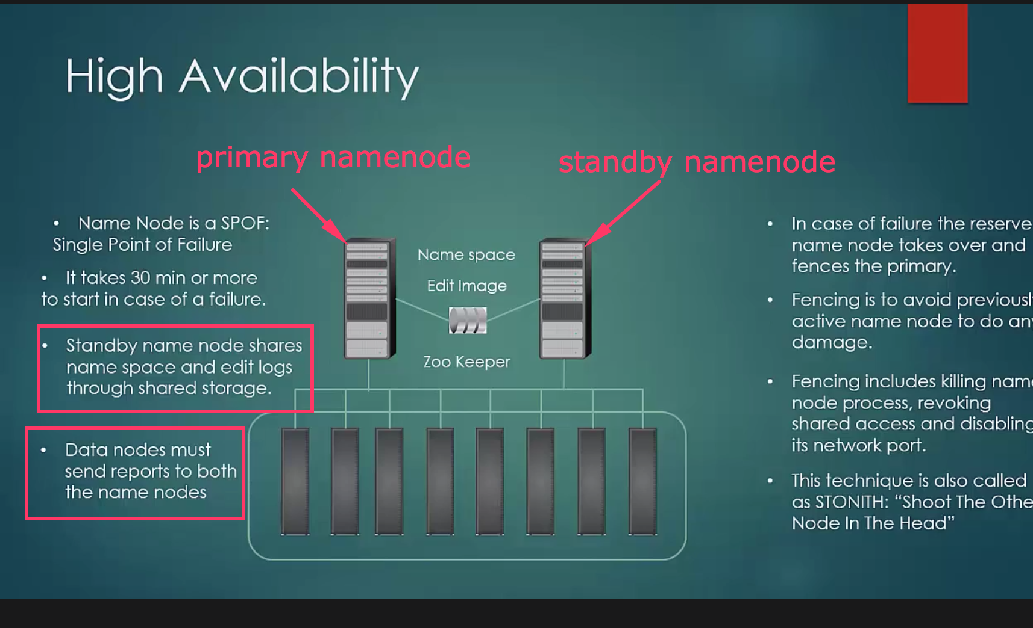

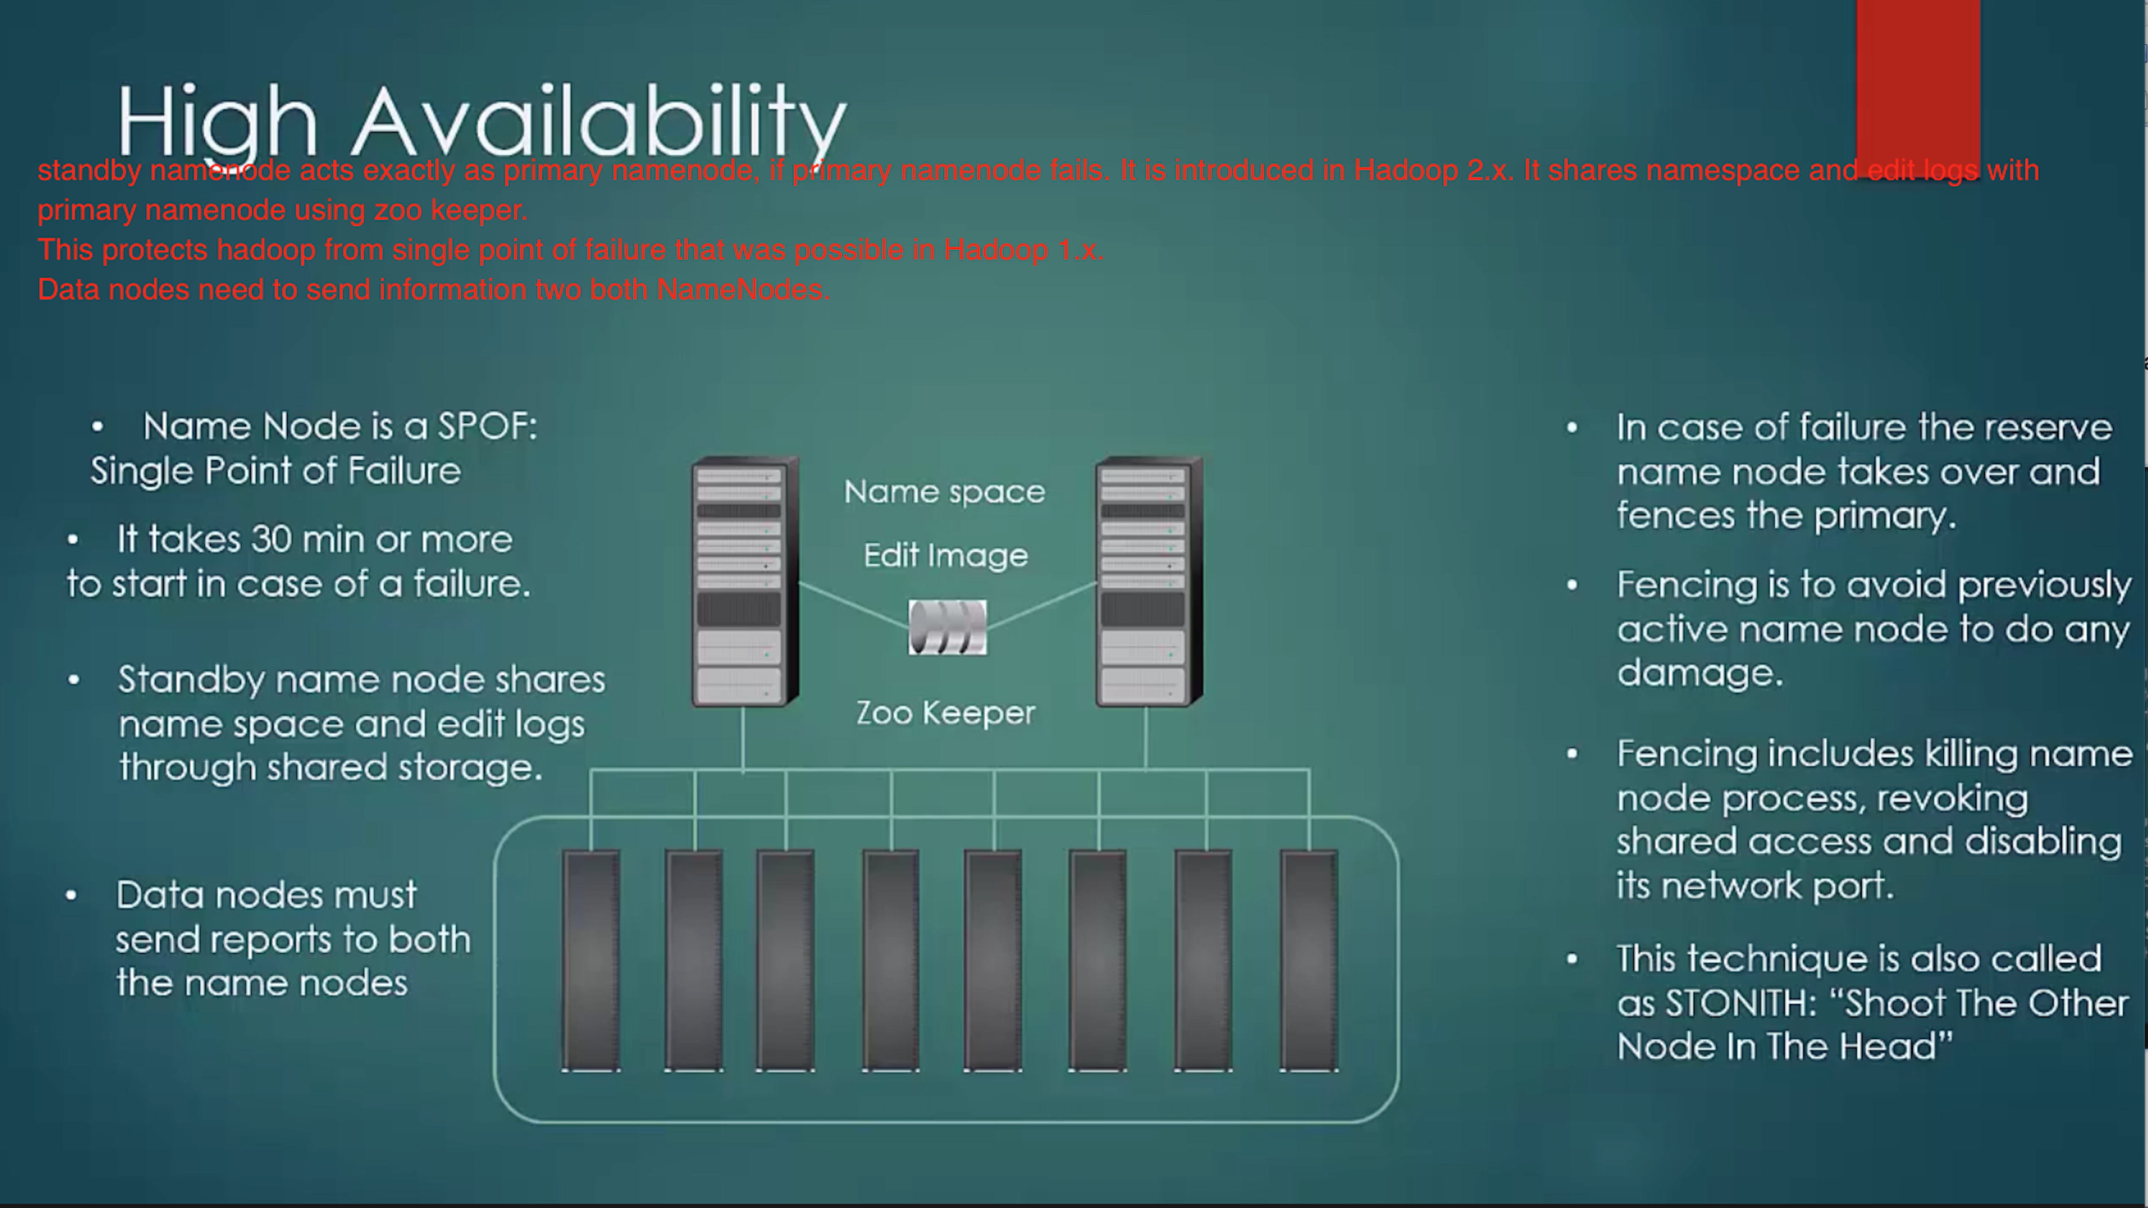

Checkpoint Node

There was also a similiar type of node called “Secondary Node” in Hadoop1, but it doesn’t have the “upload to NameNode” feature. So the NameNode need to fetch the state from the Secondary NameNode.

Backup Node

http://morrisjobke.de/2013/12/11/Hadoop-NameNode-and-siblings/

* The Backup Node provides the same functionality as the Checkpoint Node, but is synchronized with the NameNode.
* It doesn’t need to fetch the changes periodically because it receives a strem of file system edits. from the NameNode.
* It holds the current state in-memory and just need to save this to an image file to create a new checkpoint.

**HDFS Metadata**

<http://hortonworks.com/blog/hdfs-metadata-directories-explained/>

Persistence of HDFS metadata broadly breaks down into 2 categories of files:

* fsimage – An fsimage file contains the complete state of the file system at a point in time. Every file system modification is assigned a unique, monotonically increasing transaction ID. An fsimage file represents the file system state after all modifications up to a specific transaction ID.
* edits – An edits file is a log that lists each file system change (file creation, deletion or modification) that was made after the most recent fsimage.

**Checkpointing** is the process of merging the content of the most recent fsimage with all edits applied after that fsimage is merged in order to create a new fsimage.

Checkpointing is triggered automatically by configuration policies or manually by HDFS administration commands.

**NameNode and DataNode Storage Directory Structure**

<http://hortonworks.com/blog/hdfs-metadata-directories-explained/>

**HDFS Commands**

<https://hadoop.apache.org/docs/r2.7.1/hadoop-project-dist/hadoop-hdfs/HDFSCommands.html>

dfs commands

<https://hadoop.apache.org/docs/r2.4.1/hadoop-project-dist/hadoop-common/FileSystemShell.html>

These commands support most of the normal files system operations like copying files, changing file permissions, etc. It also supports a few HDFS specific operations like changing replication of files.

dfsadmin commands –

<https://hadoop.apache.org/docs/r2.4.1/hadoop-project-dist/hadoop-common/CommandsManual.html#dfsadmin>

The bin/hadoop dfsadmin command supports a few HDFS administration related operations. The bin/hadoop dfsadmin -help command lists all the commands currently supported. For e.g.:

- report: reports basic statistics of HDFS. Some of this information is also available on the NameNode front page.

- **safemode**: though usually not required, an administrator can manually enter or leave Safemode.

- finalizeUpgrade: removes previous backup of the cluster made during last upgrade.

- refreshNodes: Updates the namenode with the set of datanodes allowed to connect to the namenode. Namenodes re-read datanode hostnames in the file defined by dfs.hosts, dfs.hosts.exclude. Hosts defined in dfs.hosts are the datanodes that are part of the cluster. If there are entries in dfs.hosts, only the hosts in it are allowed to register with the namenode. Entries in dfs.hosts.exclude are datanodes that need to be decommissioned. Datanodes complete decommissioning when all the replicas from them are replicated to other datanodes. Decommissioned nodes are not automatically shutdown and are not chosen for writing for new replicas.

- printTopology : Print the topology of the cluster. Display a tree of racks and datanodes attached to the tracks as viewed by the NameNode.

**What is Safemode?**

<https://hadoop.apache.org/docs/r2.4.1/hadoop-project-dist/hadoop-hdfs/HdfsUserGuide.html#Checkpoint_Node>

During start up the NameNode loads the file system state from the fsimage and the edits log file. It then waits for DataNodes to report their blocks so that it does not prematurely start replicating the blocks though enough replicas already exist in the cluster. During this time NameNode stays in Safemode. Safemode for the NameNode is essentially a read-only mode for the HDFS cluster, where it does not allow any modifications to file system or blocks. Normally the NameNode leaves Safemode automatically after the DataNodes have reported that most file system blocks are available. If required, HDFS could be placed in Safemode explicitly using bin/hadoop dfsadmin -safemode command. NameNode front page shows whether Safemode is on or off.

**What is fsck?**

HDFS supports the fsck command to check for various inconsistencies. It is designed for reporting problems with various files, for example, missing blocks for a file or under-replicated blocks.

**What is fetchdt?**

HDFS supports the fetchdt command to fetch Delegation Token and store it in a file on the local system. This token can be later used to access secure server (NameNode for example) from a non secure client.

**What is Recovery Mode?**

Typically, you will configure multiple metadata storage locations. Then, if one storage location is corrupt, you can read the metadata from one of the other storage locations.

However, what can you do if the only storage locations available are corrupt? In this case, there is a special NameNode startup mode called Recovery mode that may allow you to recover most of your data.

You can start the NameNode in recovery mode like so: namenode –recover

**What is Rebalancer?**

HDFS data might not always be placed uniformly across the DataNode. One common reason is addition of new DataNodes to an existing cluster.

HDFS provides a tool for administrators that analyzes block placement and rebalances data across the DataNode.

**HDFS Web Interface**

NameNode and DataNode each run an internal web server in order to display basic information about the current status of the cluster. With the default configuration, the NameNode front page is at **http://namenode-name:50070/.** It lists the DataNodes in the cluster and basic statistics of the cluster. The web interface can also be used to browse the file system

**MapReduce**:

Hadoop2’s MapReduce is called MapReduce2 or YARN.

In Hadoop1, **JobTracker is a Single Point of Failure just like a NameNode in HDFS**.

To overcome this problem, JobTracker’s responsibilities are divided into multiple java processes.

**Hadoop1 MapReduce flow**

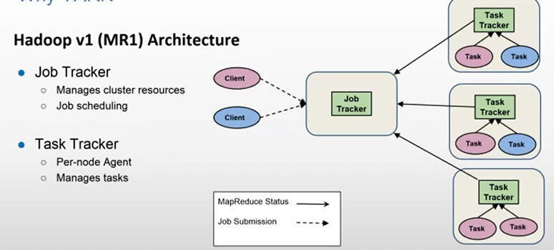

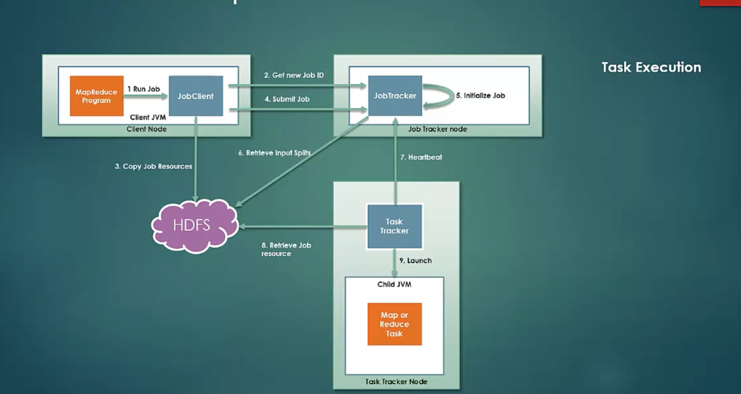

JobClient is nothing but DriverClass program that creates Job instance, which has

InputFormat type

Mapper, Combiner, Reducer classes

Output Key-Value types

etc.

JobClient (DriverClass) gets a New JobId from JobTracker

Then it copies the resources like Mapper,Combiner,Reducer programs etc to HDFS with high replication mode.

Then it submits the job to JobTracker.

JobTracker initializes a Job.

Then it takes the help of InputFormat given by JobClient to calculate the InputSplits and accordingly initialized number of Mappers.

It is continuously getting the HeartBeats from TaskTrackers. It submits the job to TaskTracker which is available and not loaded by other job works.

TaskTracker retrieves Mapper,Combiner,Reducer etc programs from HDFS and creates a new JVM instance for a new job. During the run of the job, it constantly keeps sending the status to JobTracker.

On completion of the Reducer task, it cleans up the intermittent data created by Mapper on local disc.

Finally, JobTracker sends a job completion code back to JobClient. That’s why JobClient(Driver Class) code has job.waitForCompletion() method.

Failure of a JobTracker. It is the most dangerous scenario because it’s a single point of failure in Classic MapReduce (Hadoop1). So, JobTracker should be running on a good hardware.

This situation is little improved in Hadoop2 with YARN, which is also called MapReduce2.

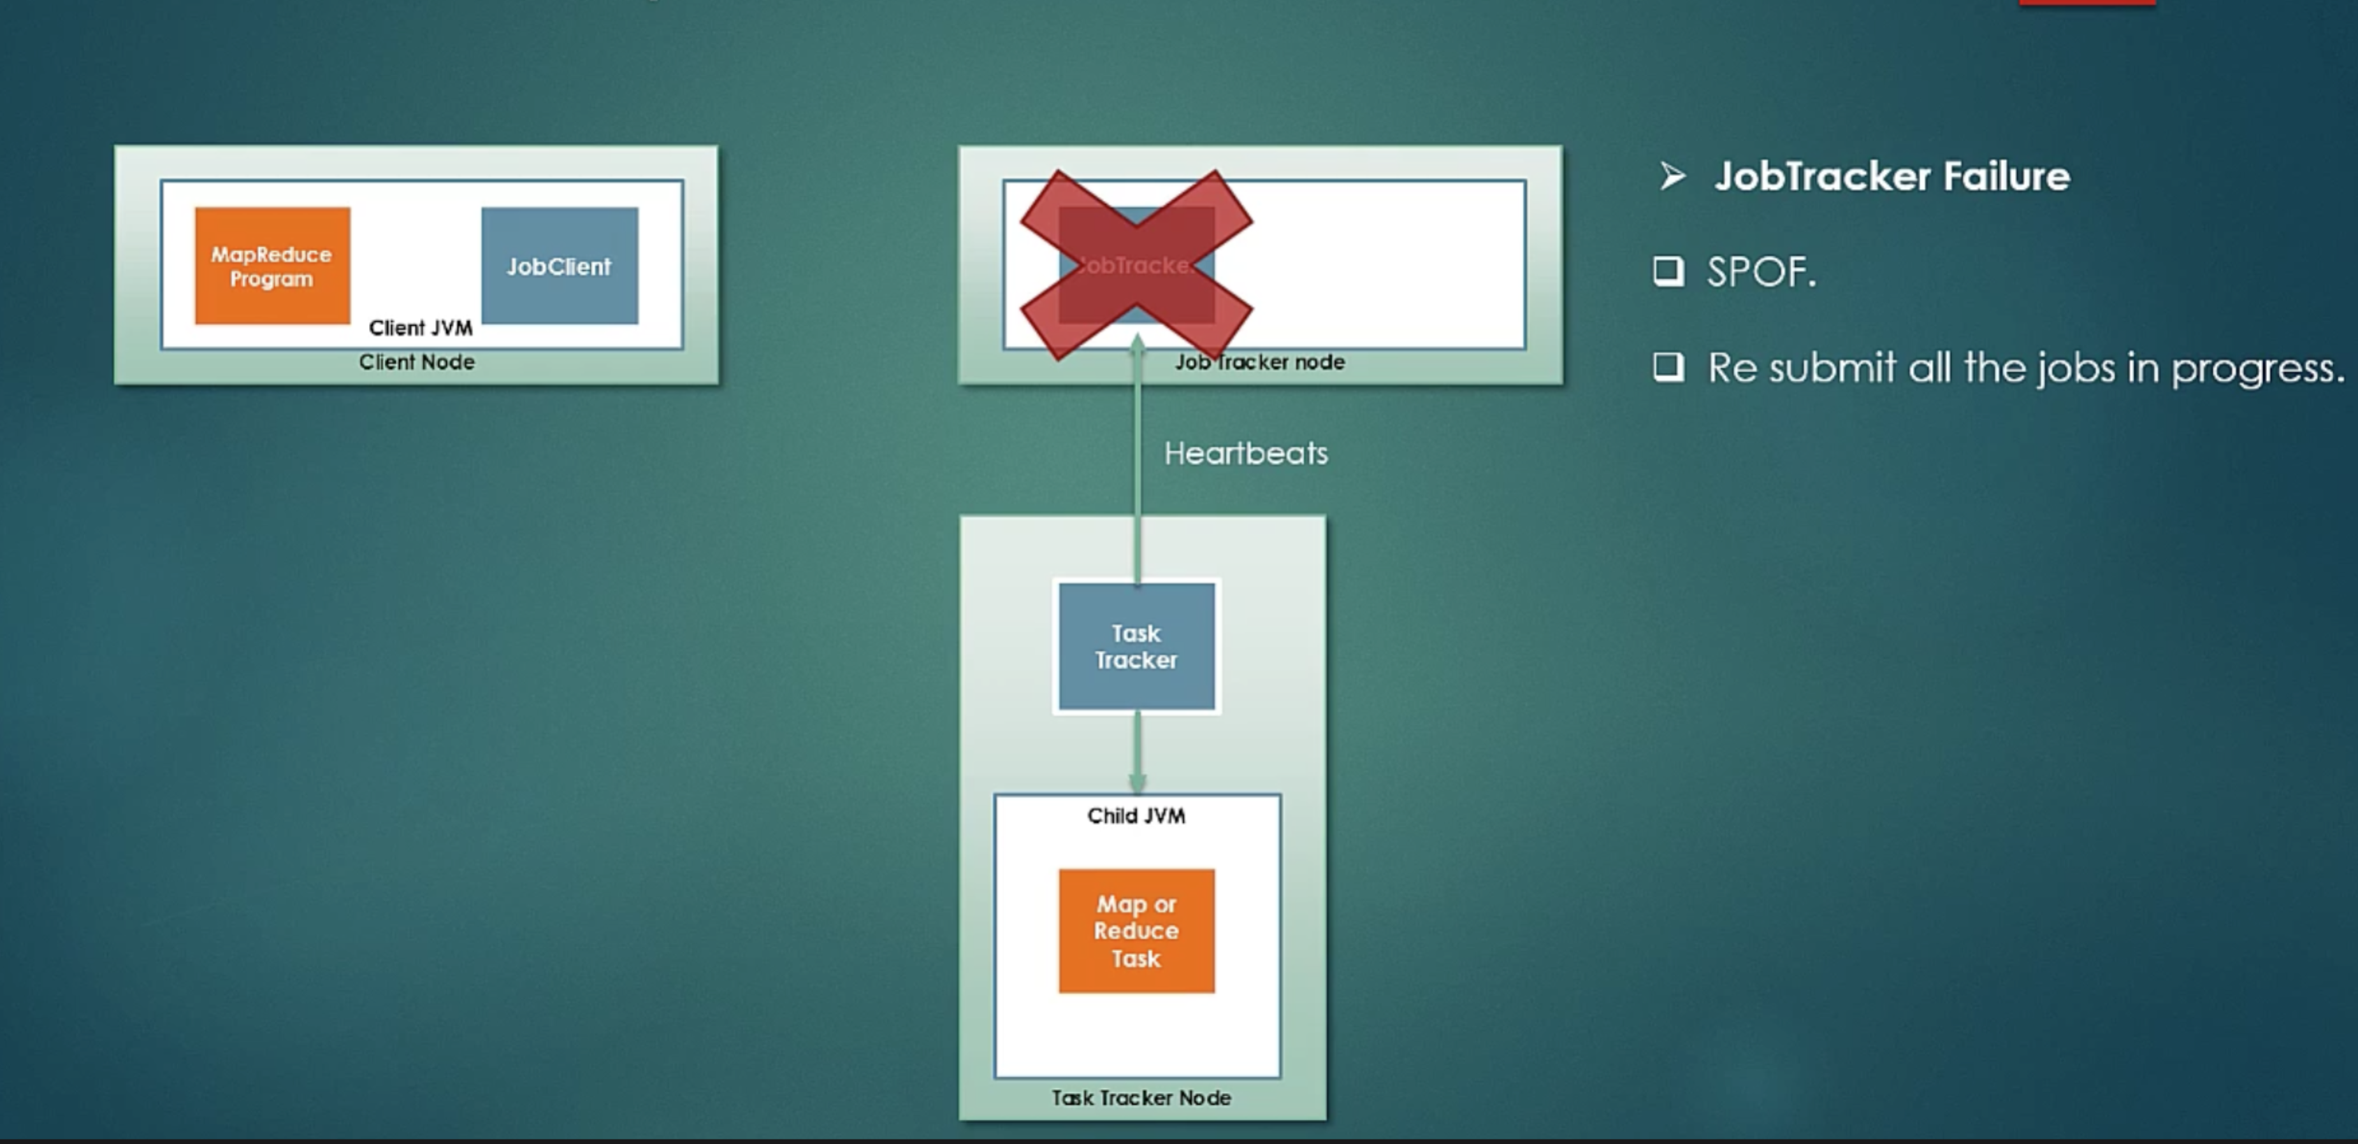

**Hadoop2 - YARN (or MapReduce2) Yet Another Resource Negotiator**

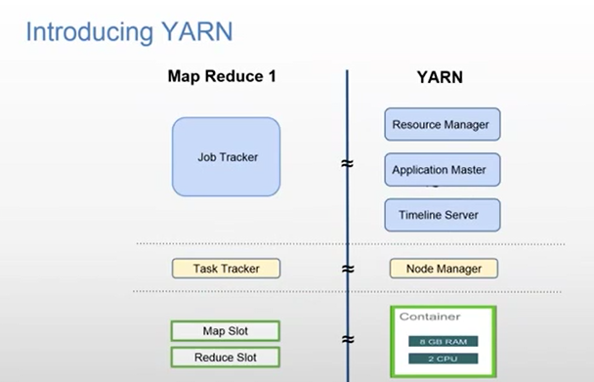

In MapReduce1, if cluster size is 4000+, then JobTracker used to be heavily loaded.

In MapReduce1, MapReduce tasks are run in memory slots. Slots can run either a Map task or a Reduce task only.

In MapReduce2, they split responsibilities of JobTracker in multiple processes.

* YARN Resource Manager
  + Job Scheduler (only does scheduling of the job)
  + Application Manager (Monitors the status and the progress of the job)
* YARN Node Manager – launch and manage containers.
* MapReduce Application Master – coordinates the running tasks, it is spawn under Node Manager on the instruction by Application Manager. A new Application Master is created for a new Job and terminated after Job completion. So, its state is temporary. So, you can consider Resource Manager as a boss who hires Application Master to coordinate a job and after the job is completed, it terminates that Application Master.
* YARN Child – It is same as TaskTracker. It runs on separate JVM than actual Mapper or Reducer task.

Unlike to TaskTracker in Hadoop1, you can not configure to run TaskTraker and Mapper/Reducer task on the same JVM.

In Hadoop1, TaskTracker used to send job statuses to JobTracker. In Hadoop2, YARN child is responsible to sends job updates to Application Master.

Due to the separation of responsibilities in Hadoop2, it can scale for 10000+ nodes per cluster.

It works on concepts of Containers. Containers are more flexible and can run both Map and Reduce tasks. It results in better memory utilization.

MapReduce code coded in MapReduce1 is still supported in MapReduce2. YARN is just a cluster side change. No change in MapReduce coding.

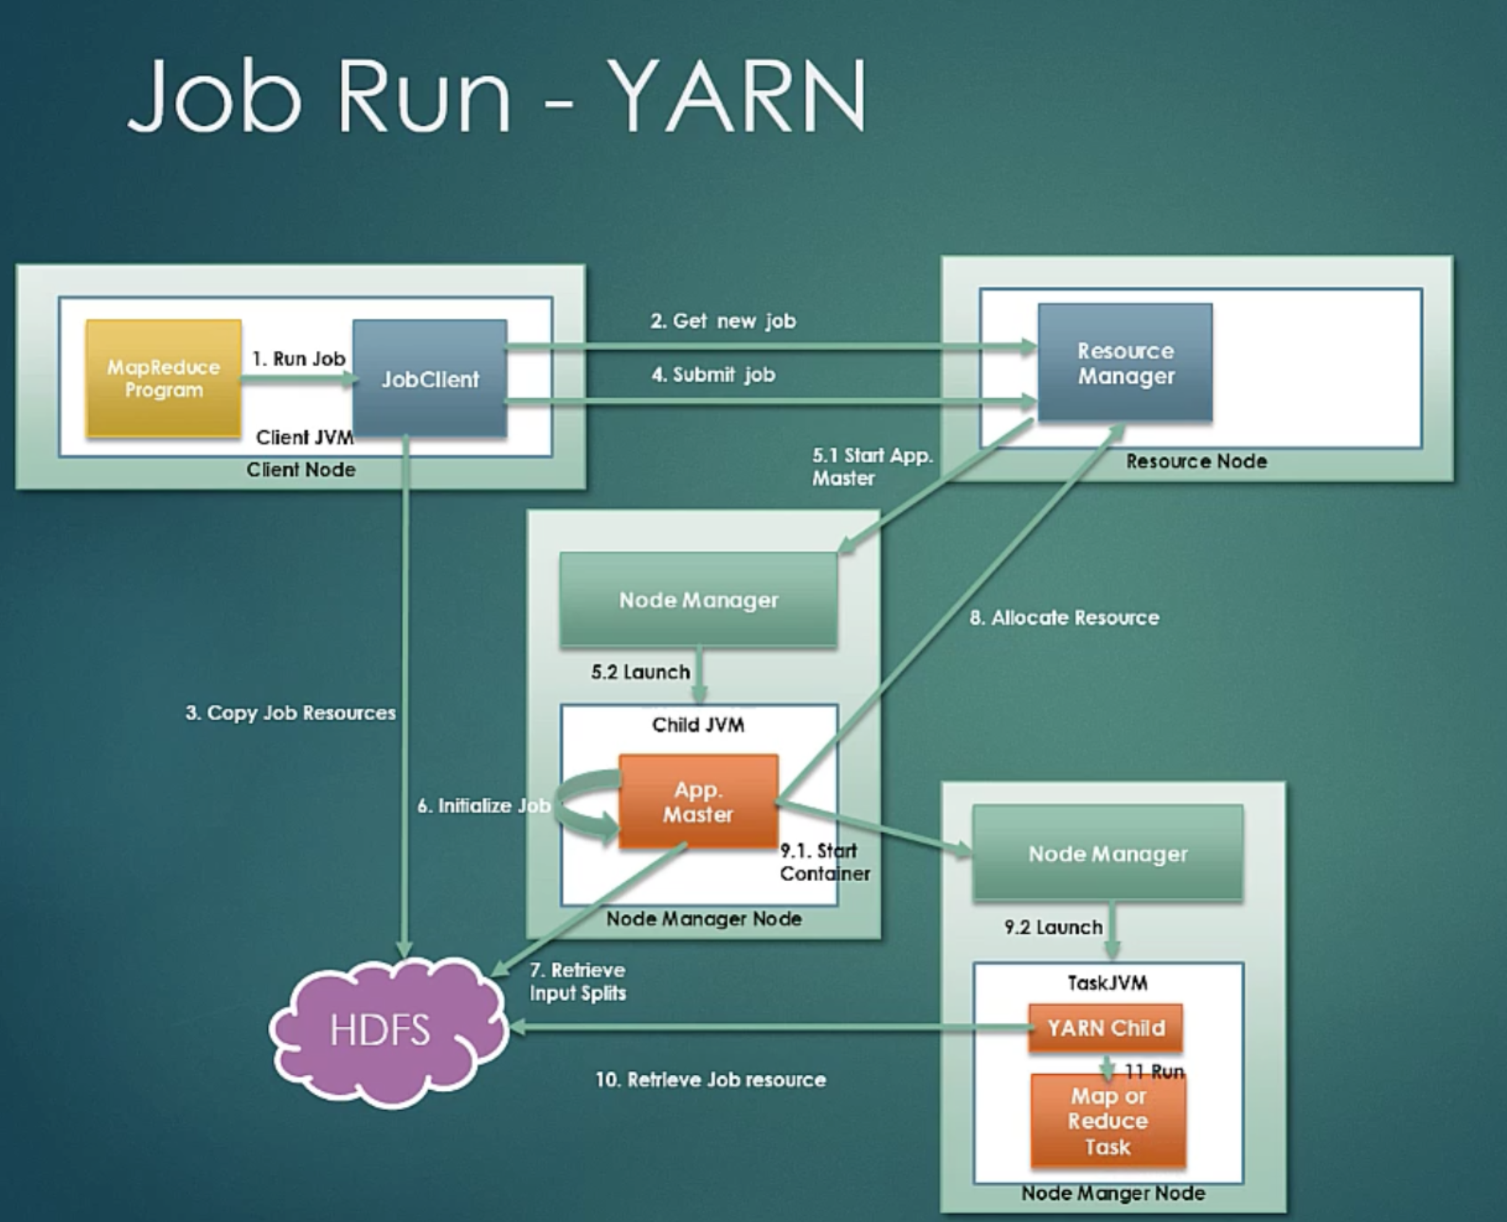

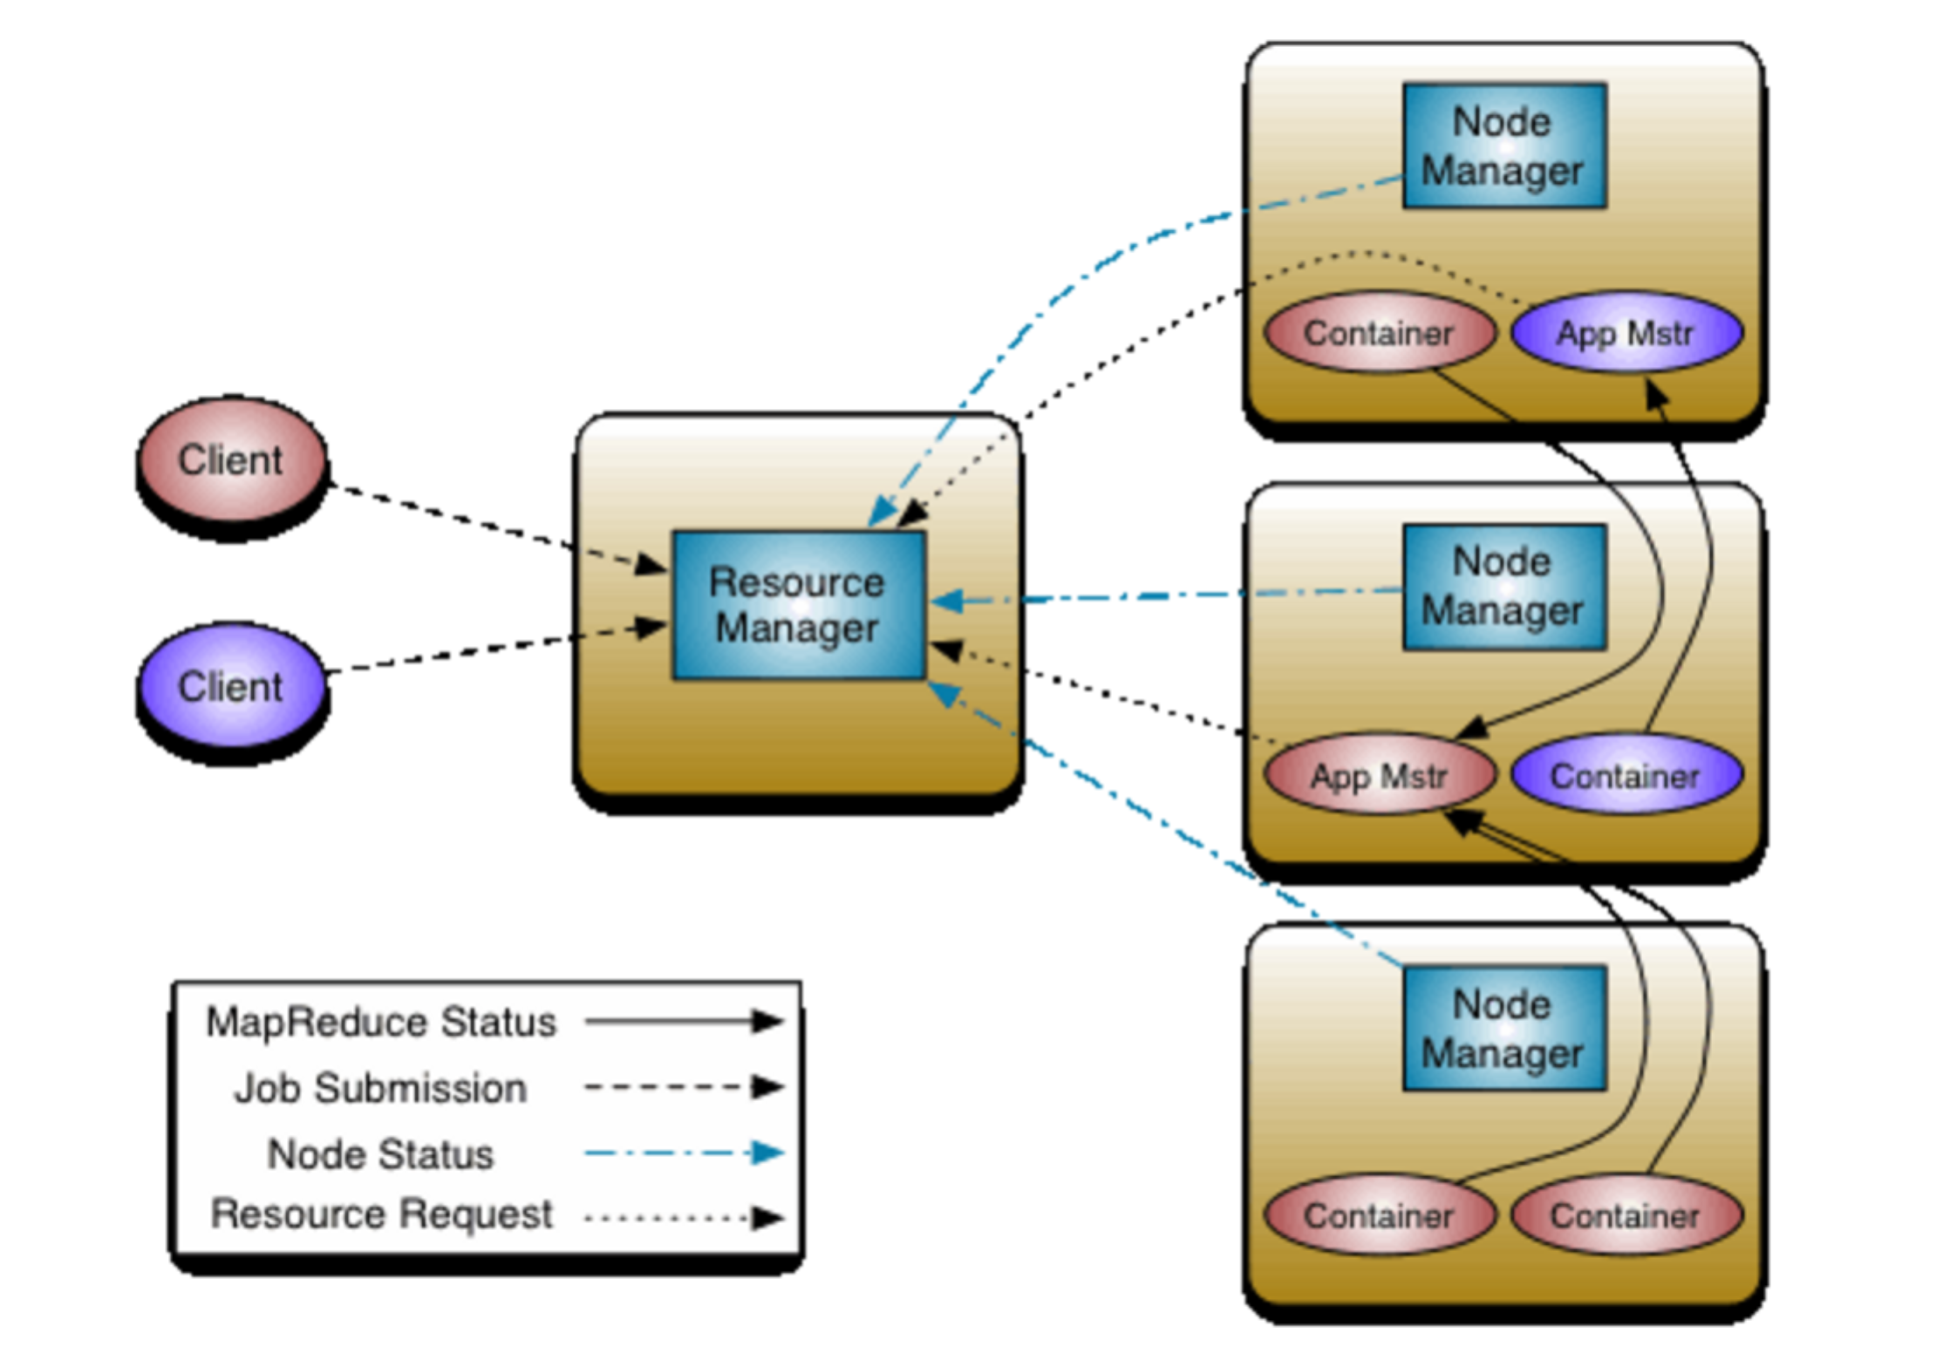

Hadoop1’s JobTracker is divided into

* **Resource Manager** (Just schedules a job and keeps track of which NodeManager nodes are up. It asks NodeManager to start AppMaster to do the remaining job)
  + **Applications Manager -** responsible for accepting job-submissions, negotiating the first container for executing the application specific ApplicationMaster and provides the service for restarting the ApplicationMaster container on failure.
  + **Scheduler** - The Scheduler is responsible for allocating resources to the various running applications subject to familiar constraints of capacities, queues etc.
* **Node Manager**
  + **Application Master** - It actually initializes the job and runs the job on its own JVM if the job is Uber(small), otherwise it contacts other NodeManagers to start a Container called YARN child that can take care of running the task.
  + **YARN Child/Container** - AppMaster under one of the NodeManager tells other NodeManagers to start Containers. Container is started by starting YARN Child java process that actually runs the Mapper or Reducer task. YARN child sends job status to AppMaster and AppMaster sends that status back to JobClient.

Hadoop1’s TaskTracker is replaced by YARN child.

JobClient requests ResourceManager to start a new Job. It identifies whether output folder already exists on HDFS. If it does then it errors out. If it doesn’t then it copes Job Resources like Mapper code, Reducer code etc to HDFS with high replication mode. Then it submits the job to ResourceManager.

ResourceManager gets a job from a queue and it starts App Master under a Node Manager.

AppMaster initializes the Job.

AppMaster decides whether a Job is small enough to be completed on the same JVM itself. It doesn’t need to take support from YARN childs from other nodes. These kind of tasks are called Uber tasks. It can reuse AppMaster’s JVM to complete its job.

If job is big, then it requests ResourceManager to allocate resources. ResourceManager gets heartbeats from NodeManagers having YARN childs, so ResourceManager knows which nodes are up and less loaded.

After getting this resource information, AppMaster asks NodeManagers on other nodes to launch CONTAINERS.

Then YARN child is launched by NodeManager. YARN child is a nothing but a java program having main() method. YARN child runs the Mapper or Reducer task. It uses separate JVM. Unlike to TaskTracker in Hadoop1, it cannot shares its JVM with Mapper or Reducer task.

YARN child retrieves all Job resources like Mapper class code, Reduce class code etc from HDFS which was copied by JobClient and starts MapReduce.

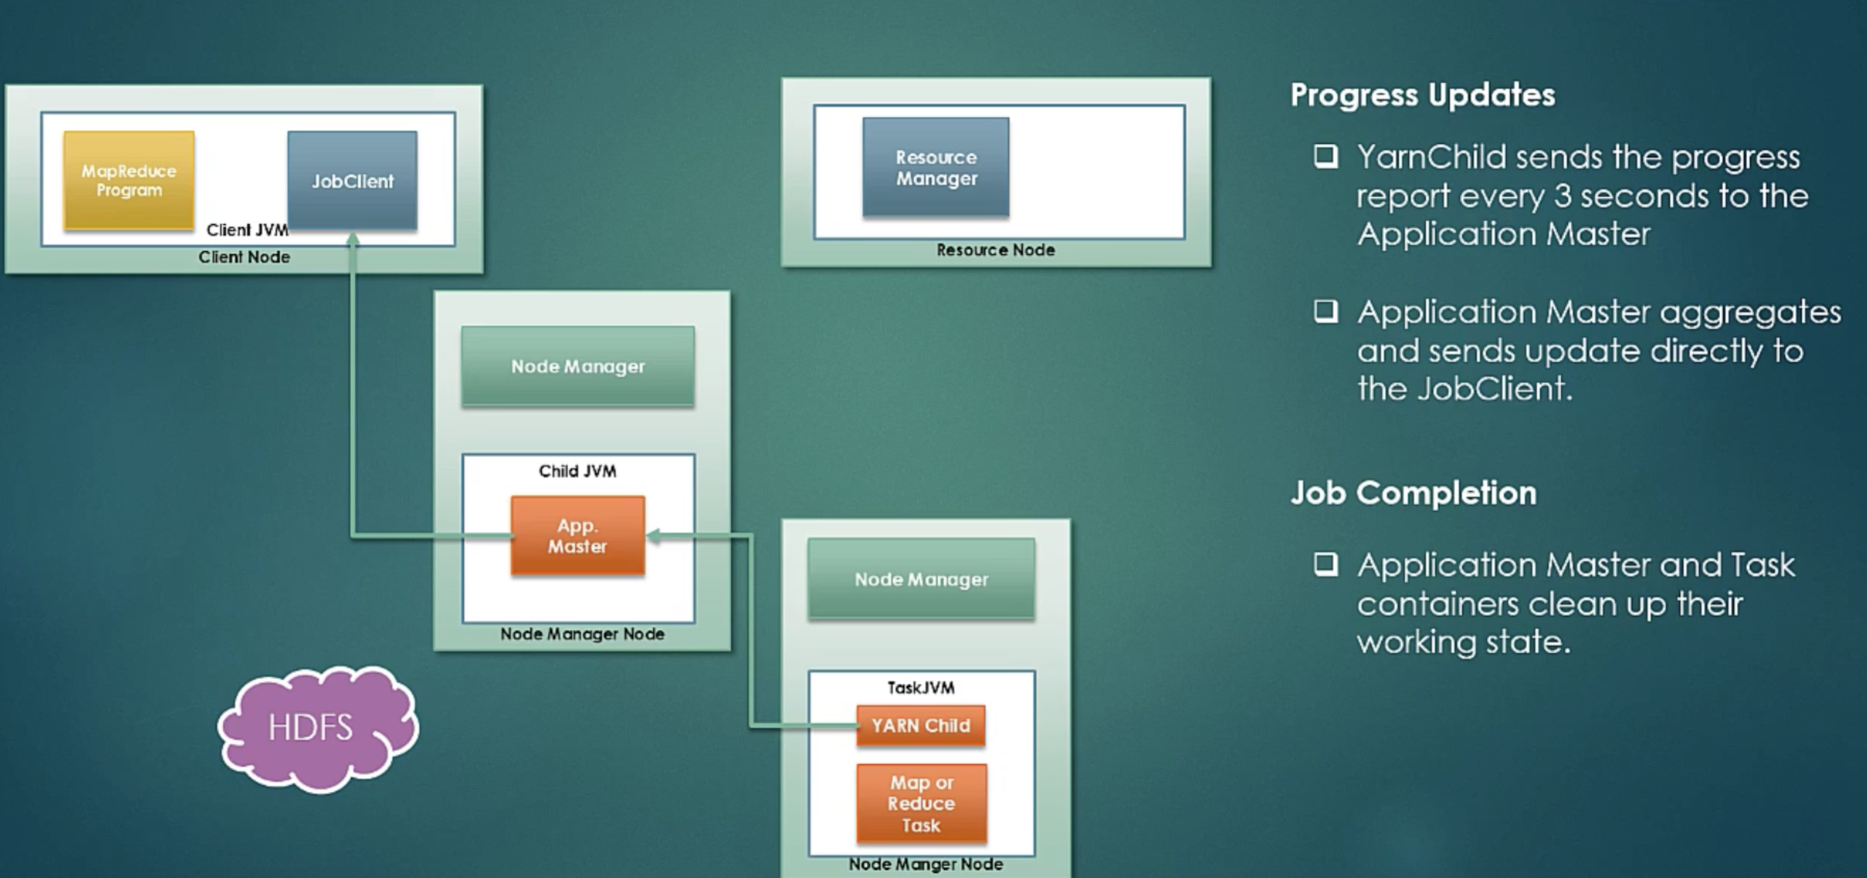

YARN child sends job status to AppMaster and AppMaster sends it to JobClient. Cleanup tasks are also carried out by AppMaster and Task Containers.

**ResourceManager’s Scheduling**

Three types

* First In first Out (FIFO) – Default in Hadoop1

It is available only in Hadoop1

* Capacity Scheduler – Default in Hadoop2 as FIFO is not available in Hadoop2

<http://hadoop.apache.org/docs/current/hadoop-yarn/hadoop-yarn-site/CapacityScheduler.html>

The CapacityScheduler is designed to run Hadoop applications as a shared, multi-tenant cluster in an operator-friendly manner while maximizing the throughput and the utilization of the cluster.

* Fair Scheduler

<http://hadoop.apache.org/docs/current/hadoop-yarn/hadoop-yarn-site/FairScheduler.html>

Fair scheduling is a method of assigning resources to applications such that all apps get, on average, an equal share of resources over time.

So far Fair Scheduler is still in Beta stage and it is still under development.

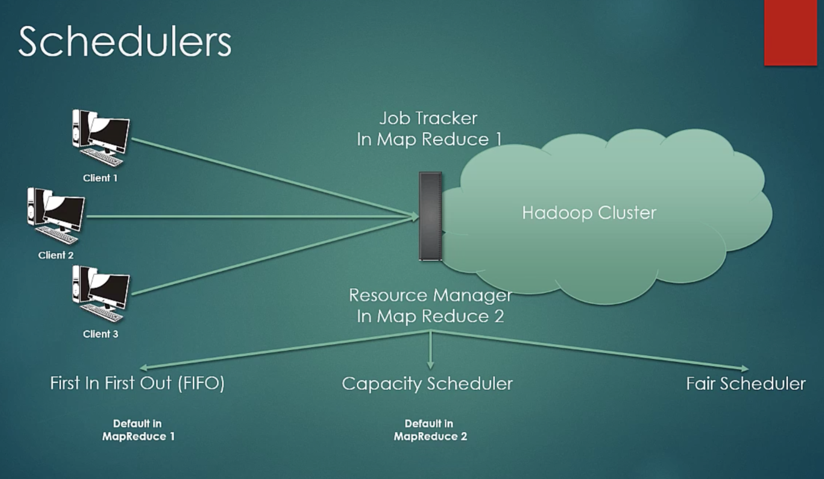

**FIFO scheduler** takes jobs as first come first basis. Let’s say, if heavy job is already taken then small jobs have to wait, but let’s say small and heavy both jobs are still in a queue and small job has higher priority, then even if heavy job has come first, it will be put behind the smaller job. This is a Priority Queue.

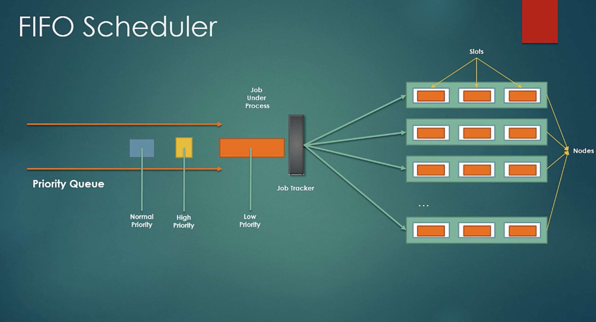

In **Capacity scheduler**, there are specific queues for multiple organizations. Here Organization is meant by type of job. You can put different types of jobs in different queues. Each organization will use a portion of a cluster.

Each Organization queue works as a FIFO queue in between that Organization’s messages.

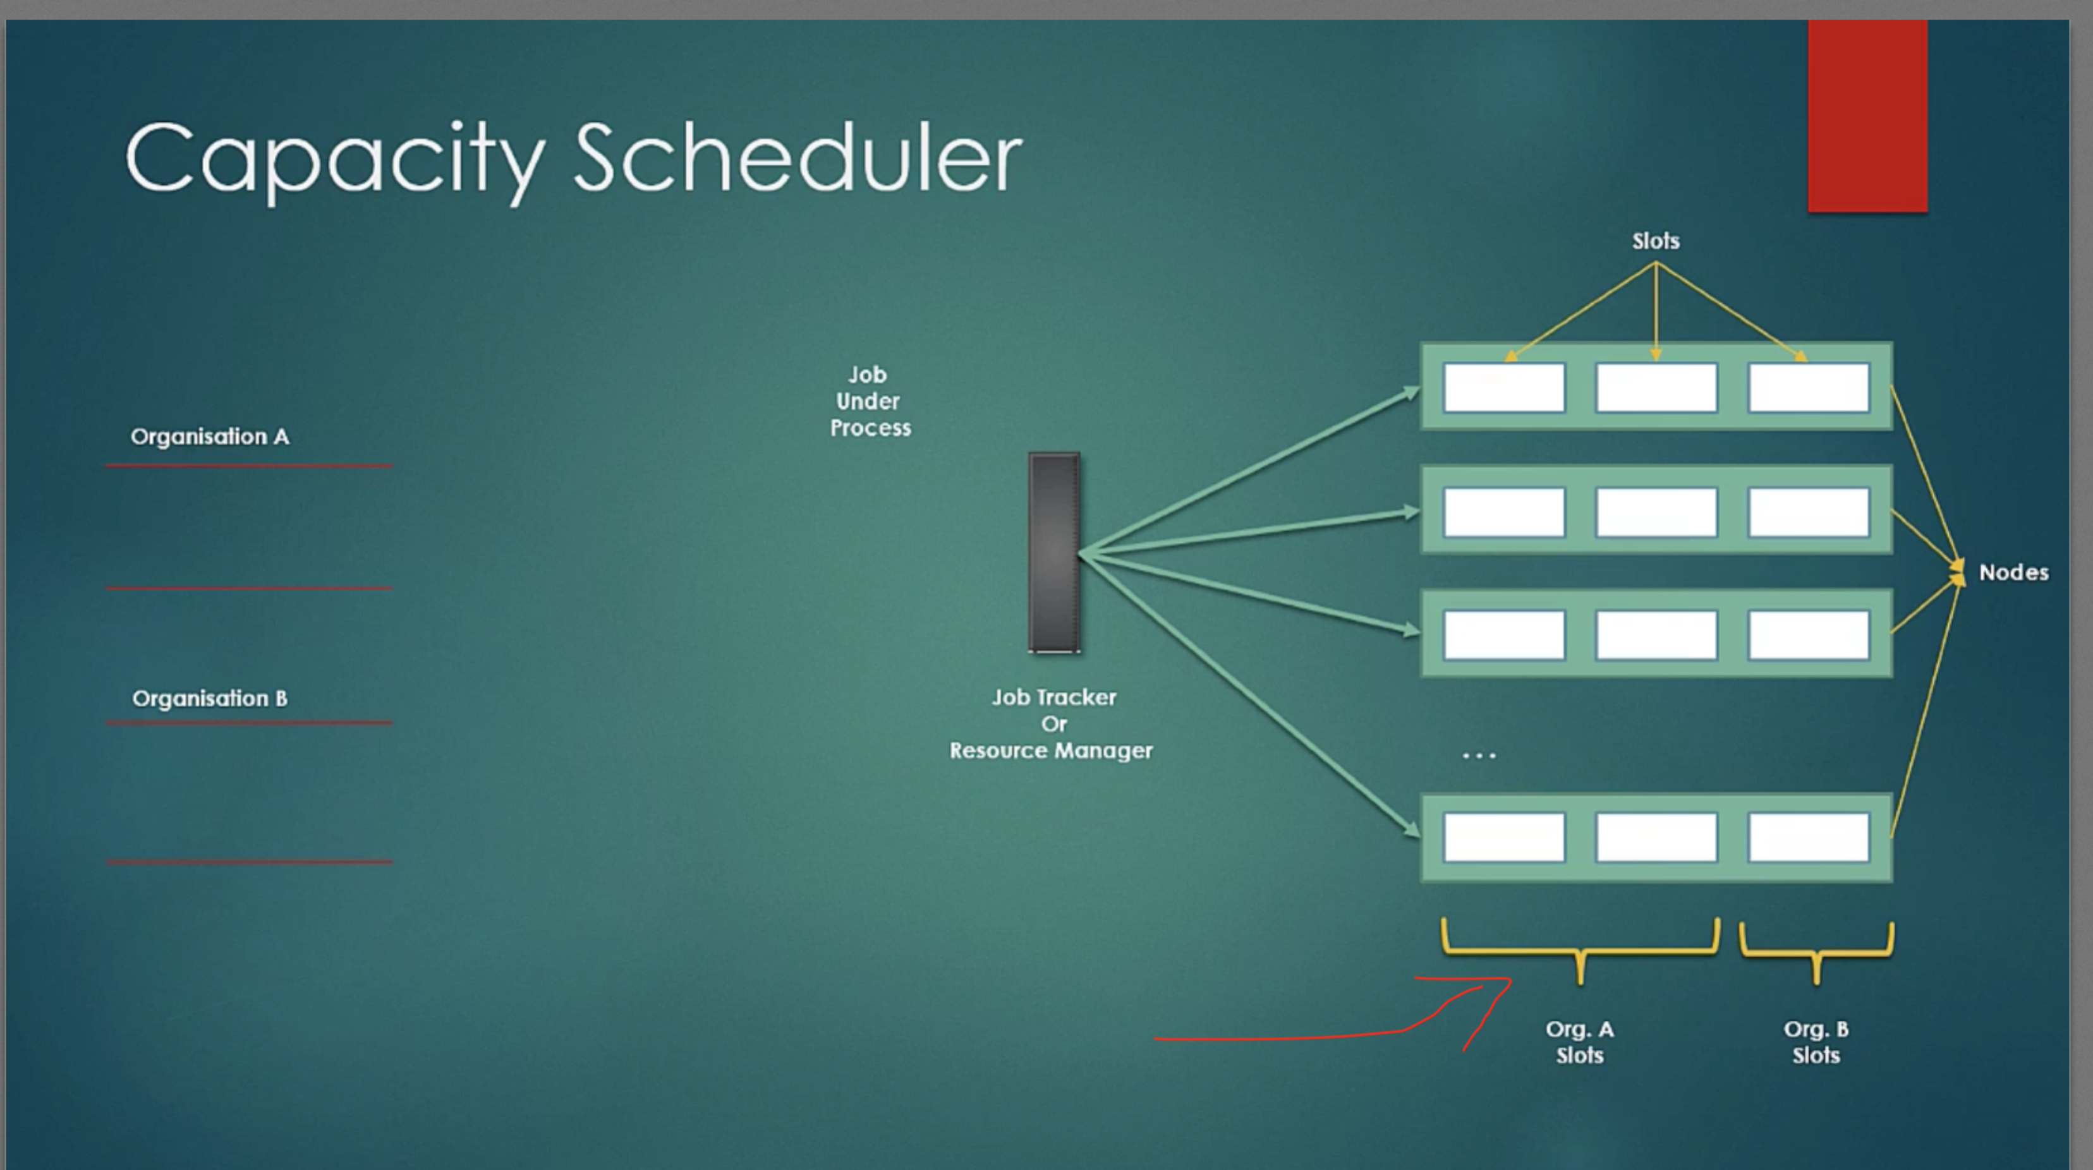

Lets say, Organization A has a job in a queue an Organization B doesn’t. In this case full capacity of the cluster will be used.

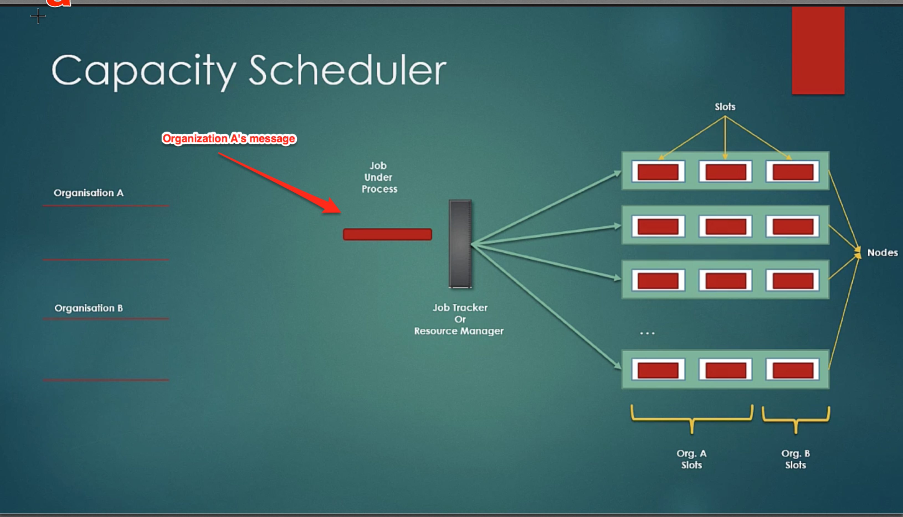

Now Organization B’s message comes in its queue. As certain slots are allocated to Organization B, running processes of Organization A will be killed in those slots and Organization B’s tasks will be packed there.

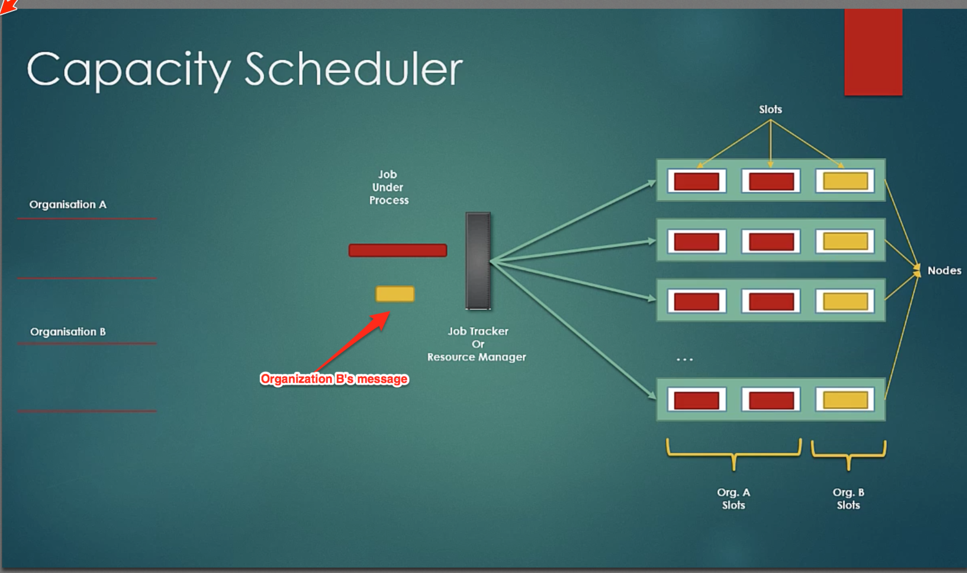

There are many features available like

1. Capacity Guarantees
2. Elasticity
3. Security

Etc.

They can be configured by administrator.

**Fair Scheduler** is quite similar to Capacity scheduler with some improvements. In Capacity scheduler message coming from the same Organization will be treated as FIFO. But in Fair Scheduler, another message will from the same Organization will also be processed in parallel to give better user experience.

In Capacity Scheduler, we call queues as Organization Queues, whereas in Fair Scheduler, we call queues as Pools.

So far Fair Scheduler is still in Beta stage and it is still under development.

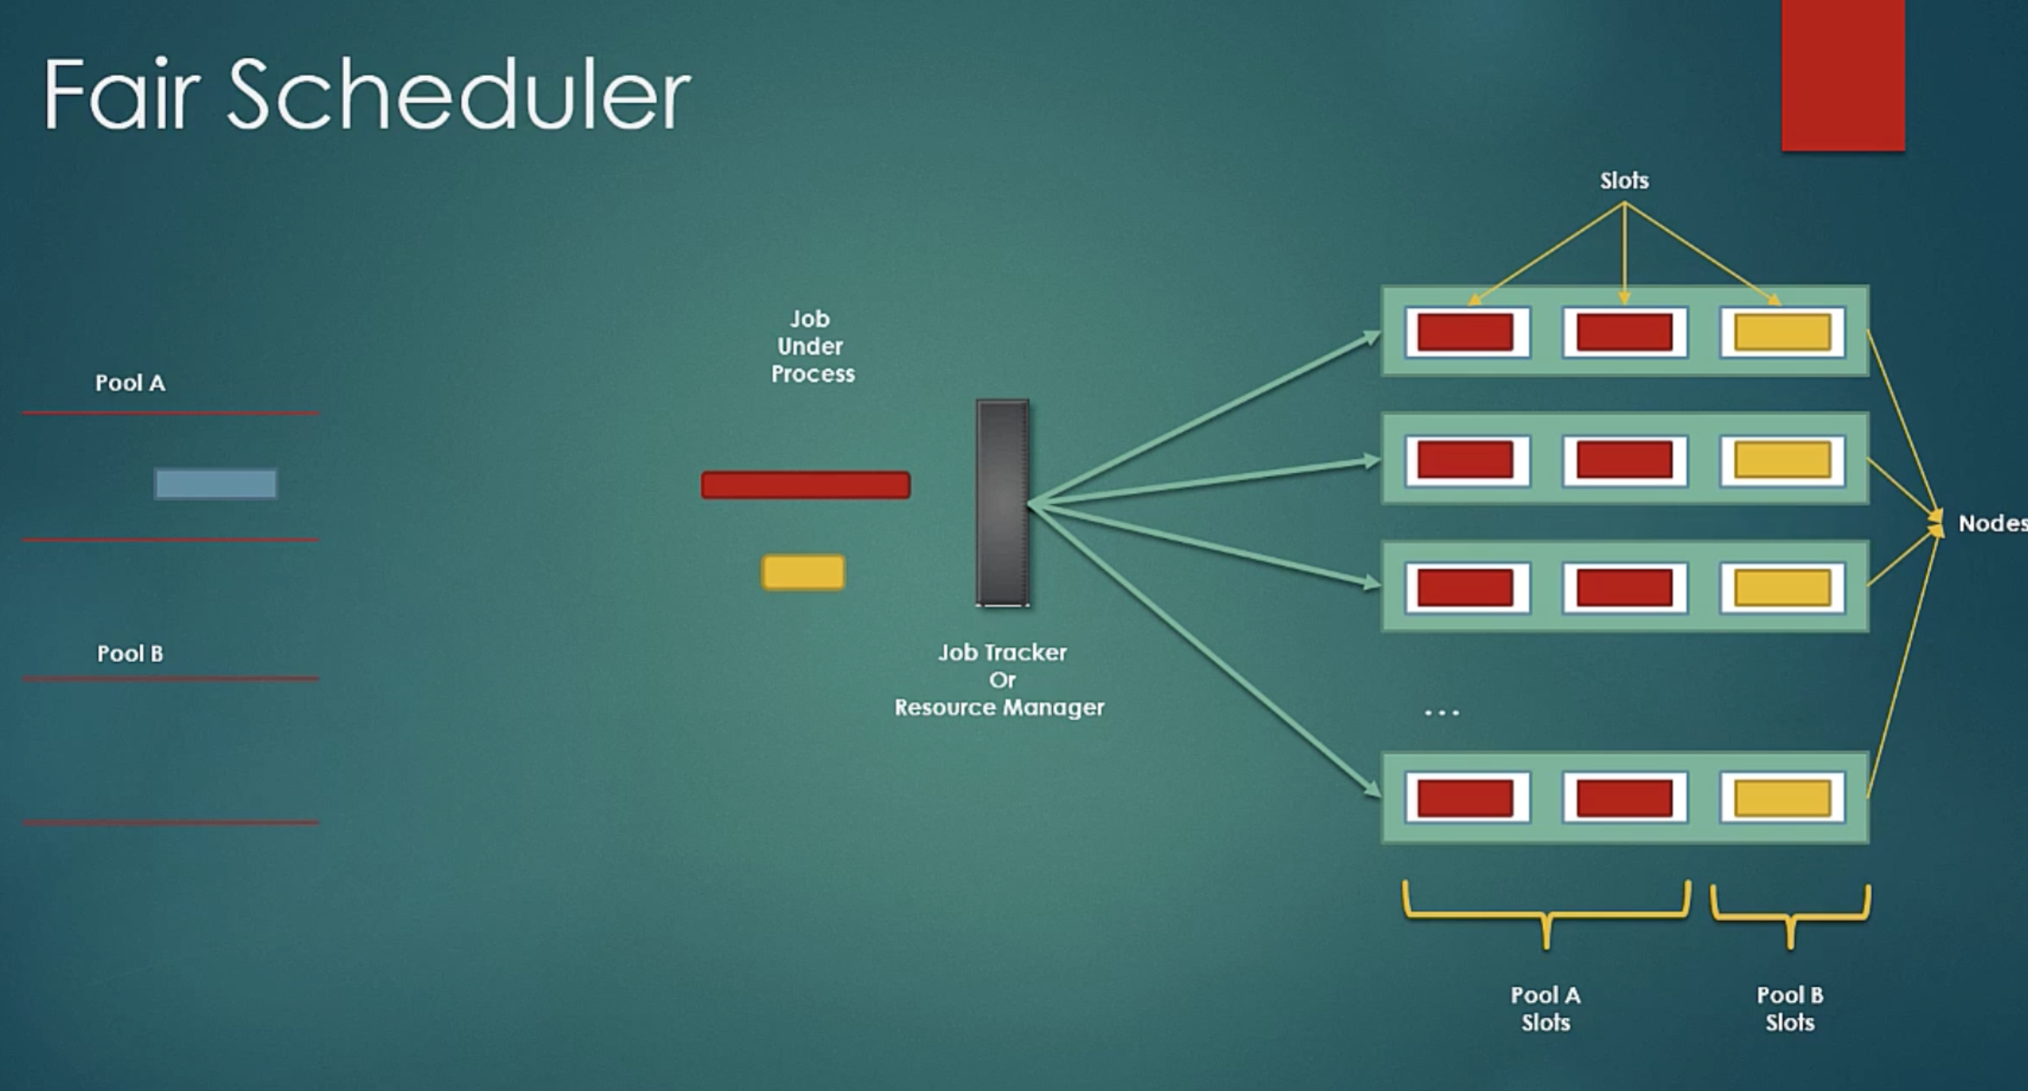

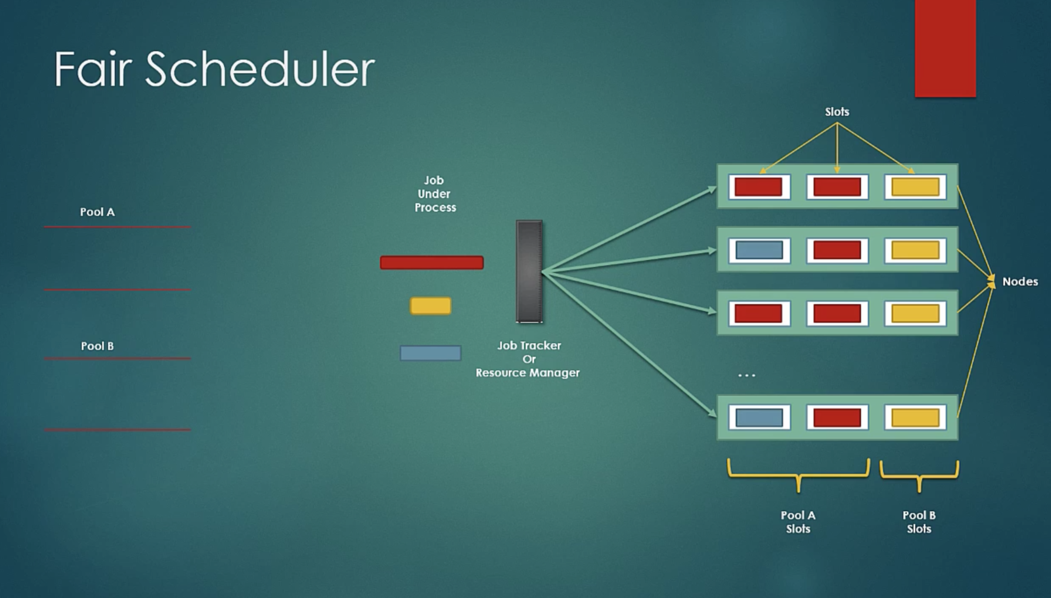

**YARN Commands**

<http://hadoop.apache.org/docs/current/hadoop-yarn/hadoop-yarn-site/YarnCommands.html>

**YARN Failure Cases**

Case1: Task fails

If task fails because of infinite loop or some runtime errors or YARN childe failure, it is reattempted as per the configuration.

Failure of Task is reattempted similar to Hadoop1. Just a property name to configure max attempts is little different. In Hadoop1, it was ‘mapred.map.max.attempts’. Here it is ‘mapred.map.maxattempts’ **.**

mapred.task.timeout

mapred.map.maxattempts

mapred.reduce.maxattempts

In very big jobs, if one or two tasks fail, then job should not be marked as failed. For that, you an use below properties.

mapred.map.failures.maxpercent

mapred.reduce.failures.maxpercent

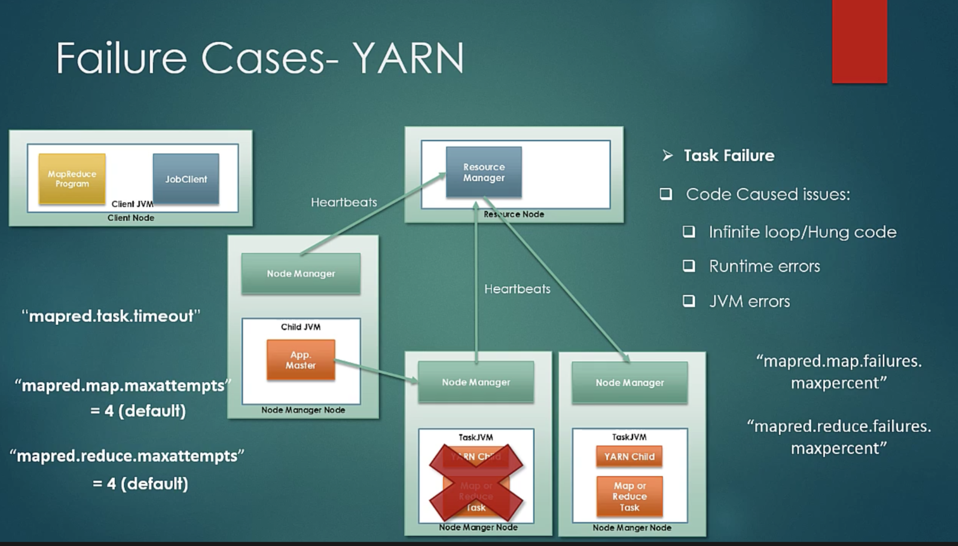

If task fails above some threshold then that Node Manager is blacklisted for some time or till it is restarted.

Case2**:** AppMaster fails

If ”yarn.app.mapreduce.am.job.recovery.enable” property is turned on, then on failure of AppMaster, YARN will create a container for AppMaster on another node and resubmit the job.

This process can be retried as set in “yarn.resourcemanager.am.max-retries” property.

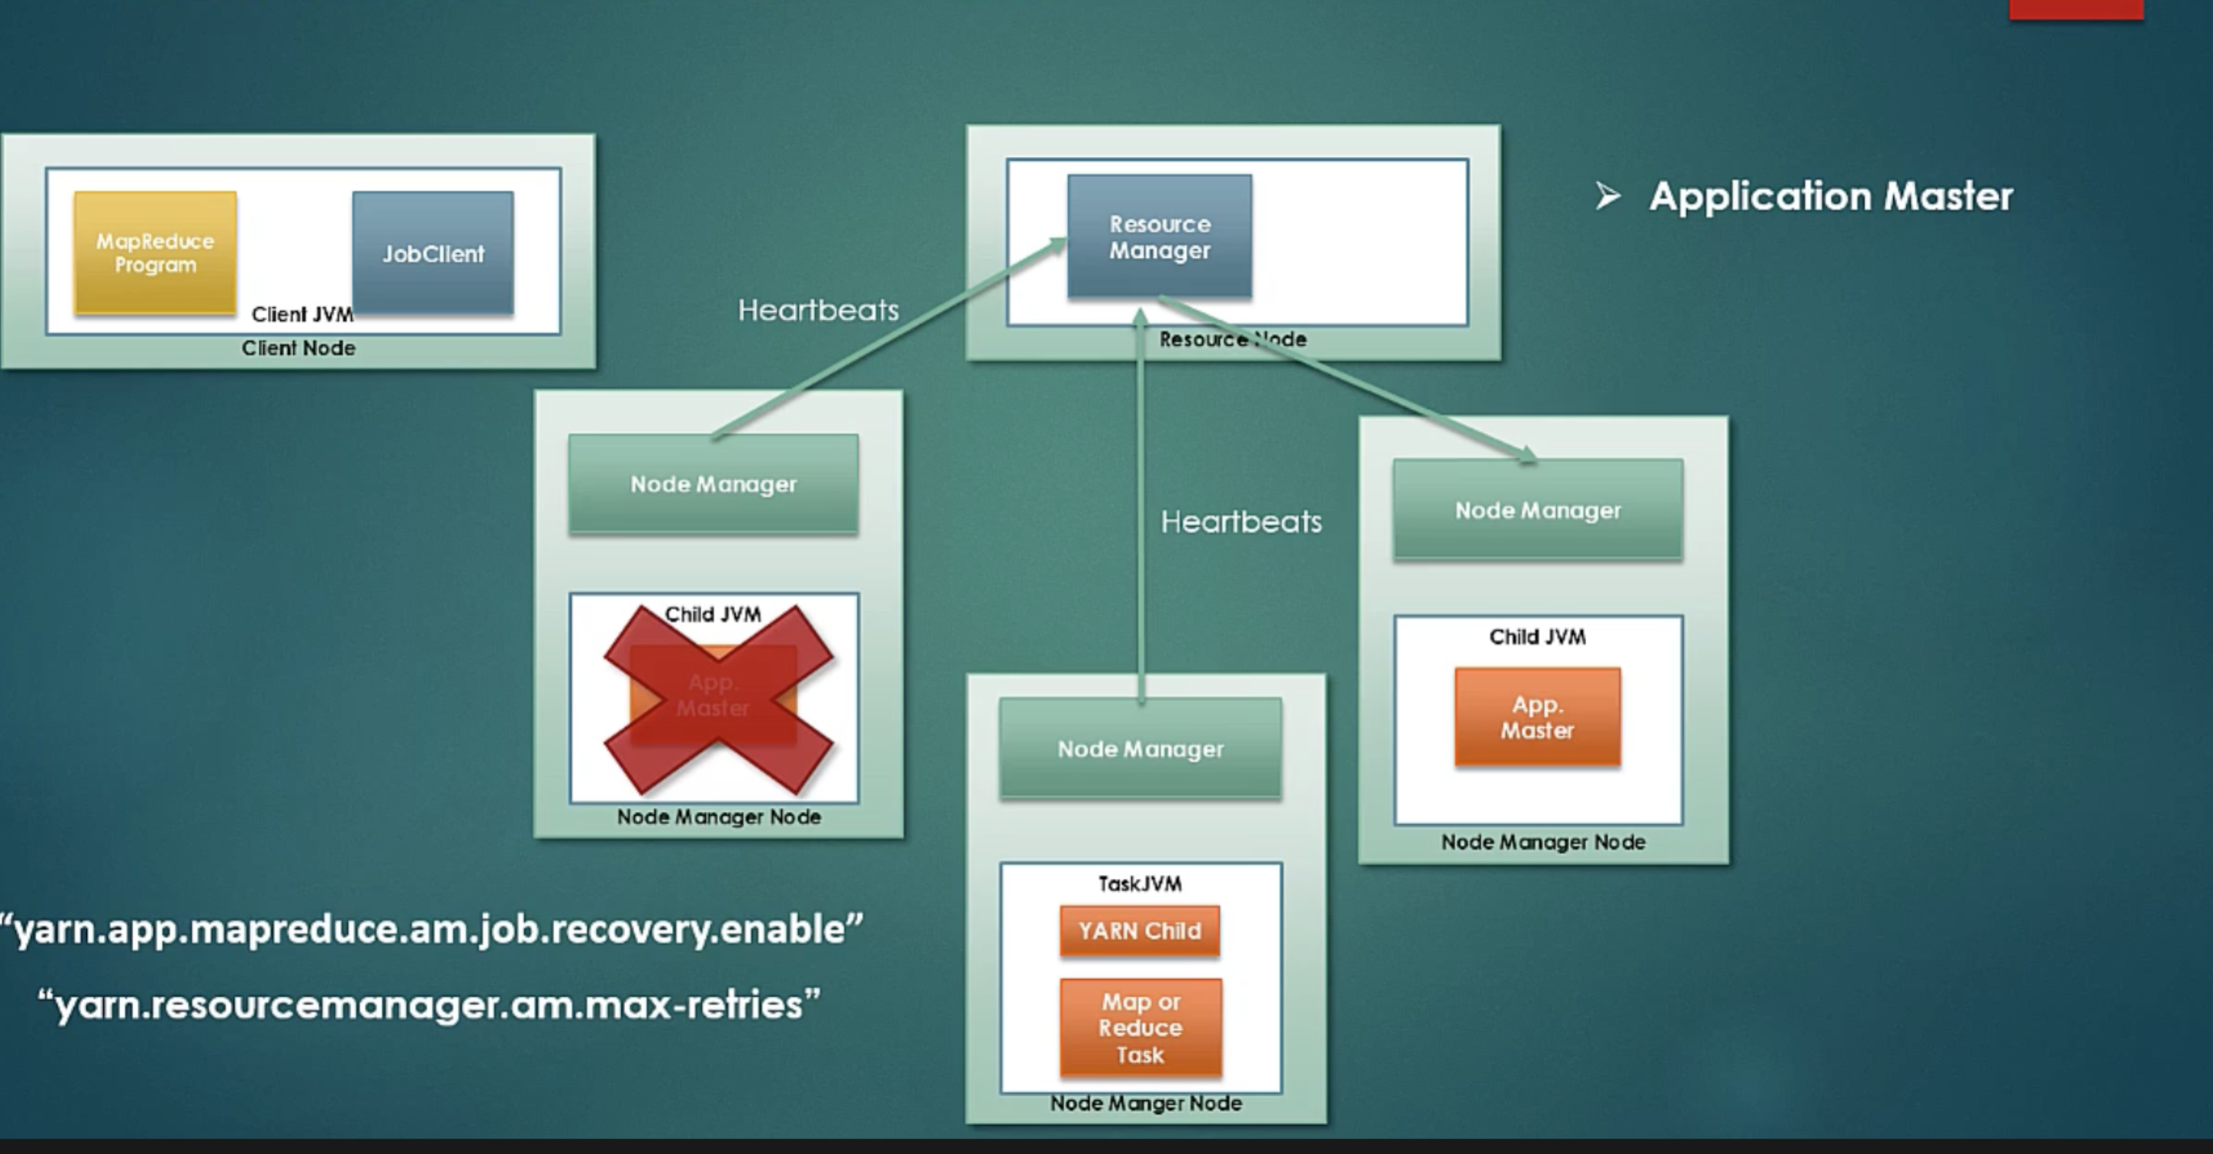

Case3: Node Manager fails

If Node Manager fails, it stops sending heartbeats to Resource Manager.

Steps described in AppMaster failure(Case 2) are followed.

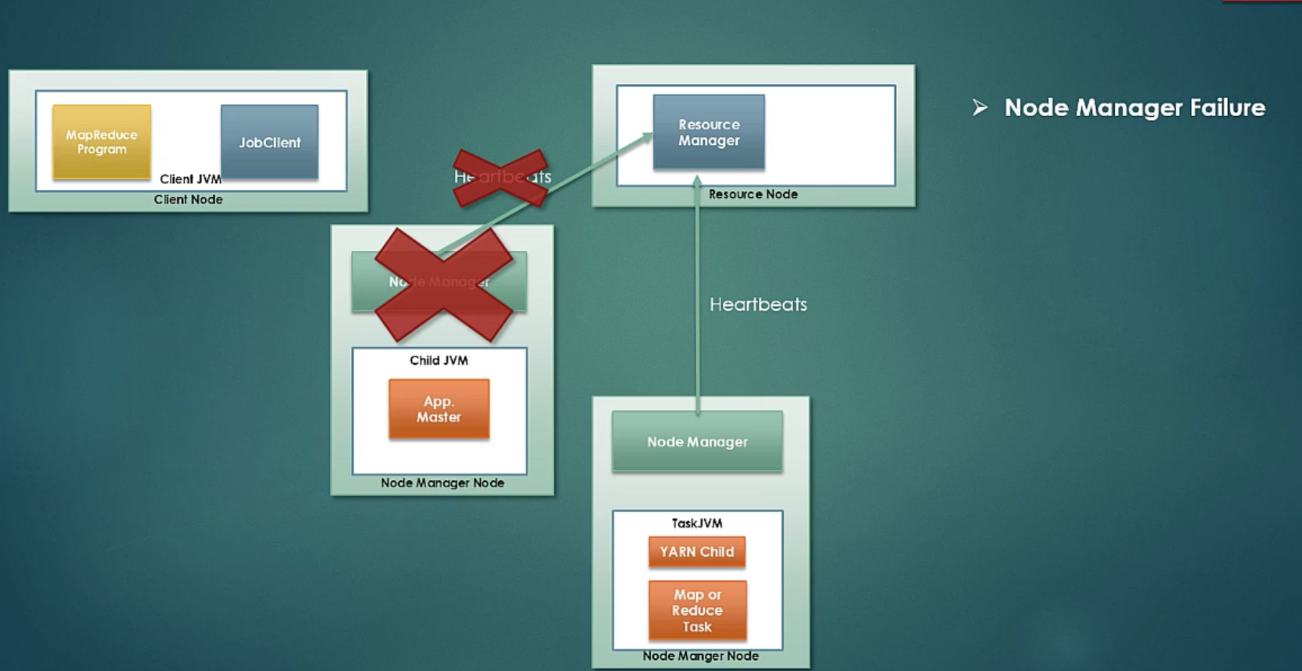

Case 4: Resource Manager fails

So, each NodeManager has AppMaster that is responsible for initiating the job and sends it status to JobClient. It means there is no Singe Point of Failure for running the jobs and sending their statuses to JobClients.

But what about ResourceMangager, is it a single point of failure(SPOF)?

Prior to Hadoop 2.4, the ResourceManager is the single point of failure in a YARN cluster. The High Availability feature adds redundancy in the form of an Active/Standby ResourceManager pair to remove this otherwise single point of failure.

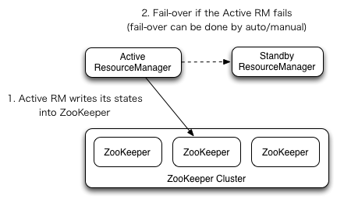

<http://hadoop.apache.org/docs/current/hadoop-yarn/hadoop-yarn-site/ResourceManagerHA.html>

The RMs have an option to embed the Zookeeper-based ActiveStandbyElector to decide which RM should be the Active. When the Active goes down or becomes unresponsive, another RM is automatically elected to be the Active which then takes over. Note that, there is no need to run a separate ZKFC daemon as is the case for HDFS because ActiveStandbyElector embedded in RMs acts as a failure detector and a leader elector instead of a separate ZKFC deamon.

With the ResourceManger Restart enabled, the RM being promoted to an active state loads the RM internal state and continues to operate from where the previous active left off as much as possible depending on the RM restart feature. A new attempt is spawned for each managed application previously submitted to the RM. Applications can checkpoint periodically to avoid losing any work. The state-store must be visible from the both of Active/Standby RMs. Currently, there are two RMStateStore implementations for persistence - FileSystemRMStateStore and ZKRMStateStore. The ZKRMStateStore implicitly allows write access to a single RM at any point in time, and hence is the recommended store to use in an HA cluster. When using the ZKRMStateStore, there is no need for a separate fencing mechanism to address a potential split-brain situation where multiple RMs can potentially assume the Active role. When using the ZKRMStateStore, it is advisable to NOT set the “zookeeper.DigestAuthenticationProvider.superDigest” property on the Zookeeper cluster to ensure that the zookeeper admin does not have access to YARN application/user credential information.

When there are multiple RMs, the configuration (yarn-site.xml) used by clients and nodes is expected to list all the RMs. Clients, ApplicationMasters (AMs) and NodeManagers (NMs) try connecting to the RMs in a round-robin fashion until they hit the Active RM. If the Active goes down, they resume the round-robin polling until they hit the “new” Active.

Here is the sample of minimal setup for RM failover in yarn-default.xml.

<property>

<name>yarn.resourcemanager.ha.enabled</name>

<value>true</value>

</property>

<property>

<name>yarn.resourcemanager.cluster-id</name>

<value>cluster1</value>

</property>

<property>

<name>yarn.resourcemanager.ha.rm-ids</name>

<value>rm1,rm2</value>

</property>

<property>

<name>yarn.resourcemanager.hostname.rm1</name>

<value>master1</value>

</property>

<property>

<name>yarn.resourcemanager.hostname.rm2</name>

<value>master2</value>

</property>

<property>

<name>yarn.resourcemanager.webapp.address.rm1</name>

<value>master1:8088</value>

</property>

<property>

<name>yarn.resourcemanager.webapp.address.rm2</name>

<value>master2:8088</value>

</property>

<property>

<name>yarn.resourcemanager.zk-address</name>

<value>zk1:2181,zk2:2181,zk3:2181</value>

</property>

**Zookeeper**

What is zookeeper?

<http://www.techburps.com/articles/apache-zookeeper/35/>

<https://www.youtube.com/watch?v=Qhc6RMaDkgY>

Hadoop 1.x does not use Zookeeper. HBase does use zookeeper even in Hadoop 1.x instlations.

Hadoop adopted Zookeeper as well starting with version 2.0.

The purpose of Zookeepr is cluster management. This fits with the general philosophy of *nix of using smaller specialized components - so components of Hadoop that want clustering capabilities rely on Zookeeper for that rather than develop their own.

Zookeeper is a distributed storage that provides the following guarantees : (copied from [Zookeeper overview page](http://zookeeper.apache.org/doc/trunk/zookeeperOver.html)):

* Sequential Consistency - Updates from a client will be applied in the order that they were sent.
* Atomicity - Updates either succeed or fail. No partial results.
* Single System Image - A client will see the same view of the service regardless of the server that it connects to.
* Reliability - Once an update has been applied, it will persist from that time forward until a client overwrites the update.
* Timeliness - The clients view of the system is guaranteed to be up-to-date within a certain time bound.

In the most basic setup, Hadoop and Hadoop-2 can work without Zookeeper i.e. YARN, HDFS and Map-Reduce (the Hadoop-2 default components) all work without Zookeeper in their most basic implementation.

You do however need Zookeeper for the HA (high availability) version of YARN (Hadoop-2) and for some versions of HA NameNode (Hadoop-1 and 2).

And some of the softwares generally considered in the Hadoop ecosystem such as HBase, Kafka, Storm and others do need it.

